Python Fabric Project

This project explains the step-by-step procedure to launch three Vagrant vm’s and shows script to execute commands from one vm to multiple vm using Python Fabric.

1. Place the below script in a vagrant file - ‘Vagrantfile’ and do vagrantup and launch 3 instances(scriptbox, web01 and web02)

Vagrant.configure("2") do |config|

config.vm.define "scriptbox" do |scriptbox|

scriptbox.vm.box = "ubuntu/bionic64"

scriptbox.vm.hostname = "scriptbox"

scriptbox.vm.network "private_network", ip: "192.168.10.2"

end

config.vm.define "web01" do |web01|

web01.vm.box = "centos/7"

web01.vm.hostname = "web01"

web01.vm.network "private_network", ip: "192.168.10.3"

web01.vm.provider "virtualbox" do |vb|

vb.memory = "1024"

vb.cpus = 2

end

end

config.vm.define "web02" do |web02|

web02.vm.box = "centos/7"

web02.vm.hostname = "web02"

web02.vm.network "private_network", ip: "192.168.10.4"

end

end

1. Ssh into scriptbox,

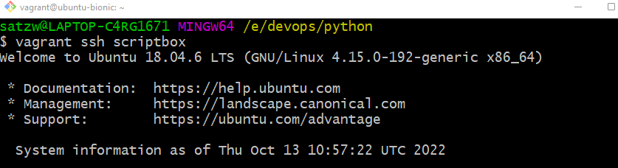

1. Download pip(not install) using the below commands,

wget <https://bootstrap.pypa.io/get-pip.py>

curl -O https://bootstrap.pypa.io/pip/2.7/get-pip.py <- use this

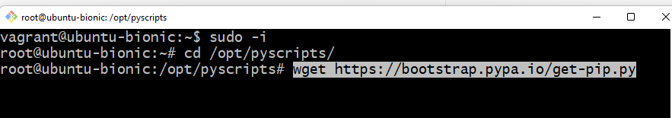

1. Install Python 2. Fabric supports python2

apt install python

1. Install pip using python.

python get-pip.py

1. To install fabric.

pip install 'fabric<2.0'

1. Create a fabfile with the below content and execute from shell

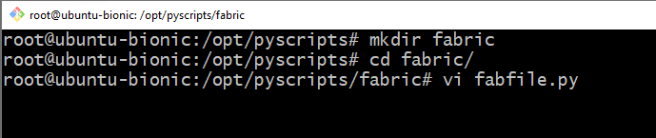

def greeting(msg):

print "Good %s"% msg

To list the functions defined in the fabfile

fab –l

To execute the function with value,

fab greeting:Evening

To execute local system commands,

from fabric.api import *

def system_info():

print "Disk Space"

local("df -h")

print "RAM size"

local("free -m")

print "System uptime"

local("uptime")

1. Execute task on remote machine
   1. Login to remote machine web01 and create users first

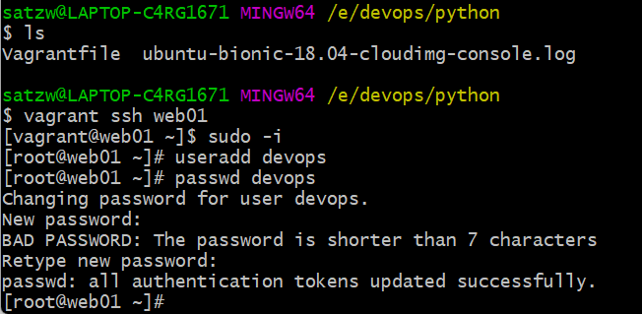

* 1. Edit sudoers file, and make sure user devops should have root privilege, add the below highlighted..

visudo

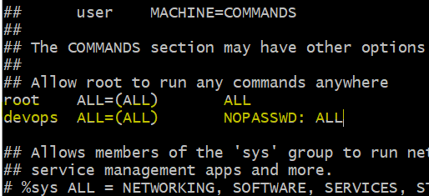

vi /etc/ssh/sshd_config and update the pwd auth to yes

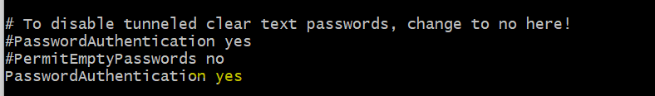

* 1. Restart sshd service.

systemctl restart sshd

* 1. Repeat the same for web02
  2. From scriptbox check whether we can ssh into web01 and web02.

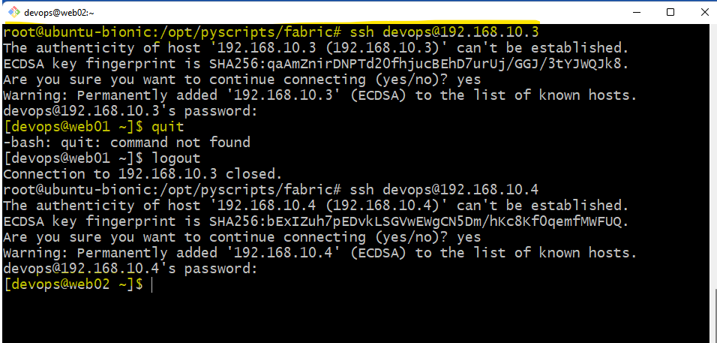

1. Create a keygen and add it to web01 and for web02.

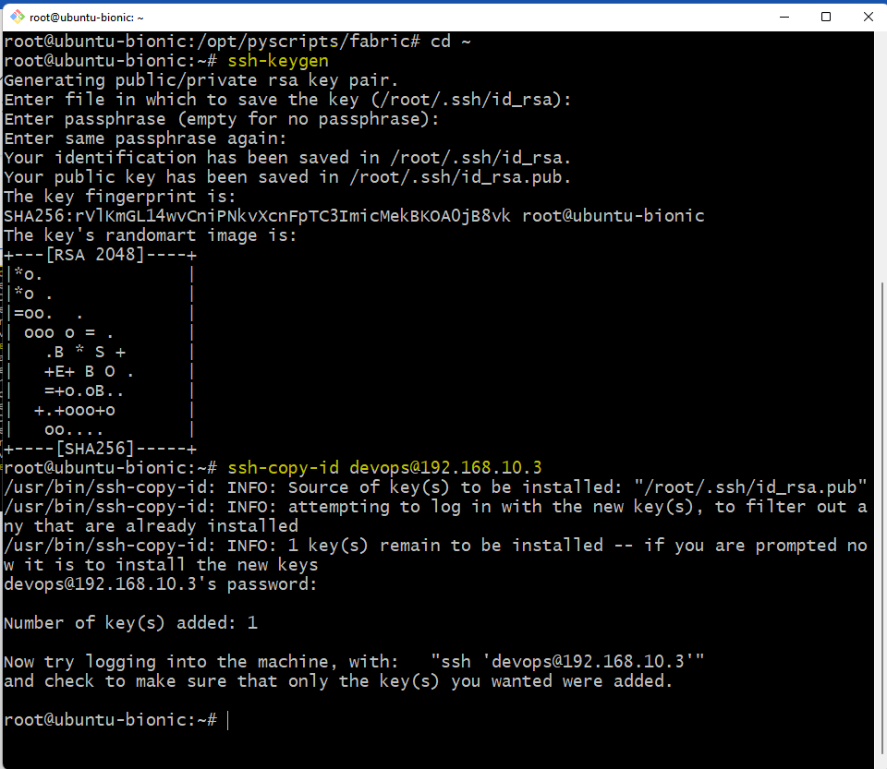

1. Now try to execute a command with fab by providing hostname, no key will be required.

root@ubuntu-bionic:/opt/pyscripts/fabric# fab -H 192.168.10.3 -u devops remote_exec

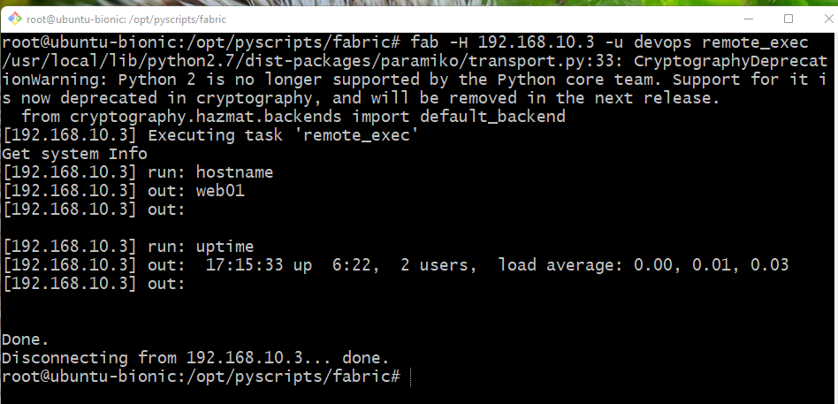

Added sudo command will execute with root privilege.

sudo("yum install mariadb-server -y")

sudo("systemctl start mariadb")

sudo("systemctl enable mariadb")

To download a website in scriptbox vm and push it to web01 vm.

def web_setup(WEBURL, DIRNAME):

print "###################################################################################"

local("apt install zip unzip -y")

print "###################################################################################"

print "Installing dependencies"

print "###################################################################################"

sudo("yum install httpd wget unzip -y")

print "###################################################################################"

print "Start & enable service."

print "###################################################################################"

sudo("systemctl start httpd")

sudo("systemctl enable httpd")

print "###################################################################################"

print "Downloading and pushing website to webservers."

print "###################################################################################"

local(("wget -O website.zip %s") % WEBURL)

local("unzip -o website.zip")

print "###################################################################################"

with lcd(DIRNAME):

local("zip -r tooplate.zip * ")

put("tooplate.zip", "/var/www/html/", use_sudo=True)

with cd("/var/www/html/"):

sudo("unzip -o tooplate.zip")

sudo("systemctl restart httpd")

print "Website setup is done."

Execute below in shell

fab -H 192.168.10.3 -u devops web_setup:https://www.tooplate.com/zip-templates/2121_wave_cafe.zip,2121_wave_café

